**Project 1**

**<Battle Game>**

**Xin Xiang**

**CSC 5---42829**

**05/02/2016**

**Game’s Name: Battle Game**

**Summary:**

This game is similar with old cellphone game that a player picks up a character, who is set up in the game, and has a main story line to fight with bosses in the game. Due to the limitation of my own knowledge, this game only can be displayed as words form.

At the very beginning, players press “y” or “Y” to enter into the game and press “N” or “n” to exit the game. Then, game tells players what initial conditions they have such as HP, MP, and Damage. Later, players will meet up with the first boss and players have two options: fight or escape. Fight, players will fight with boss; escape, players will find another path and eventually die of a trap. A few rounds after, players defeat boss and step into next boss(Roshan). Same options for players whether they plan to fight or not. Then, if players’ HP is too low, they will be asked to have HP flask and use ultimate mana spell.

**Introduction:**

Project Size: 192 lines

The number of variables: 15

The methods: 4

In this project, due to that I liked battle game when I was young, I decided to build up this small game. However, I only used word form to display the character-boss fight. For the most of fights, I used “while” loop to determine their rounds so that they can have fair fights. Also, I added having-hp-flask part up into my program. This is one of the hardest part I have been through because at the very beginning character would have HP flasks whenever its hp is lower than 150 which is not what I required. My design is to let character have only one time to have HP flask. Also, the other hardest part is how to set proper, reasonable, and logic parameters for damage and HP.

**Flow Charts**

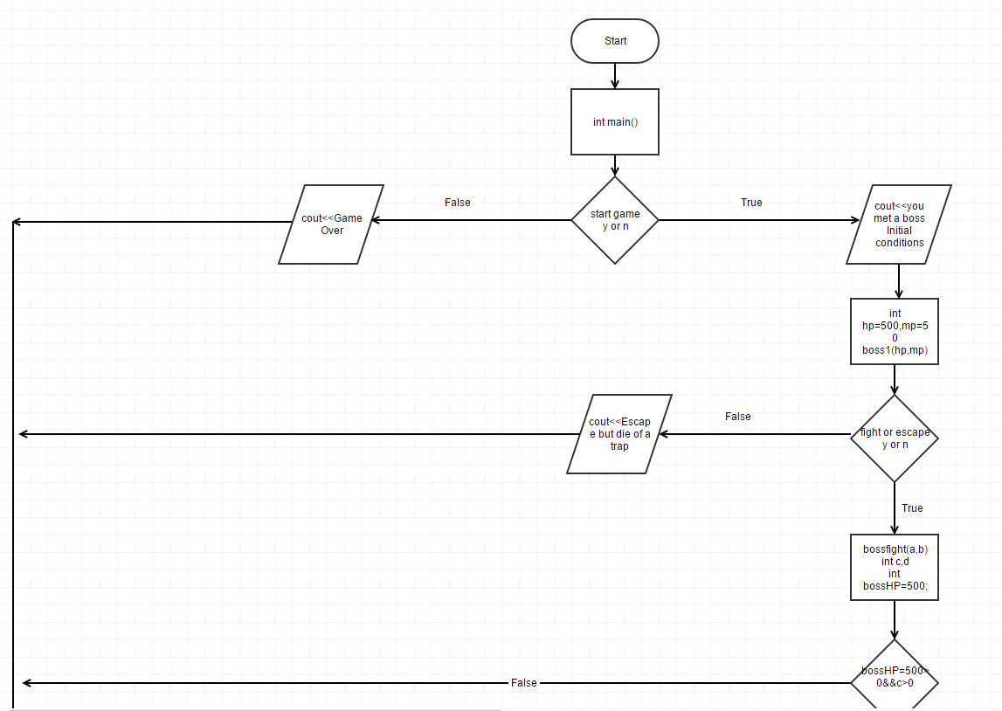

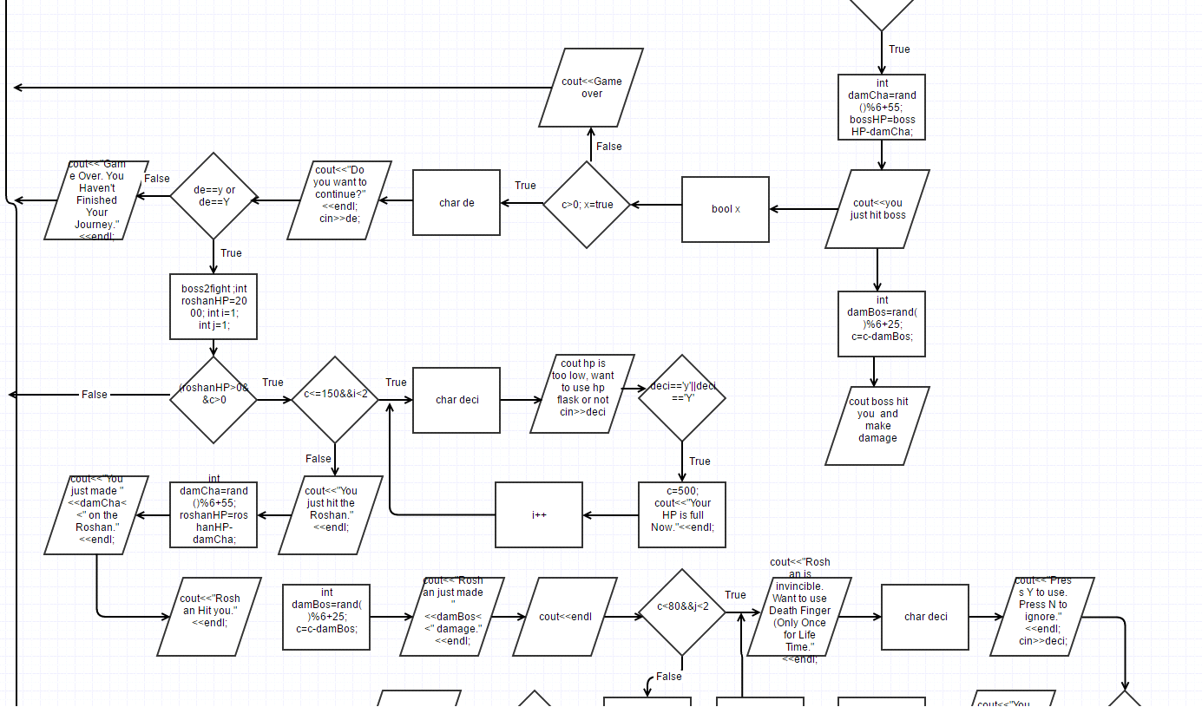

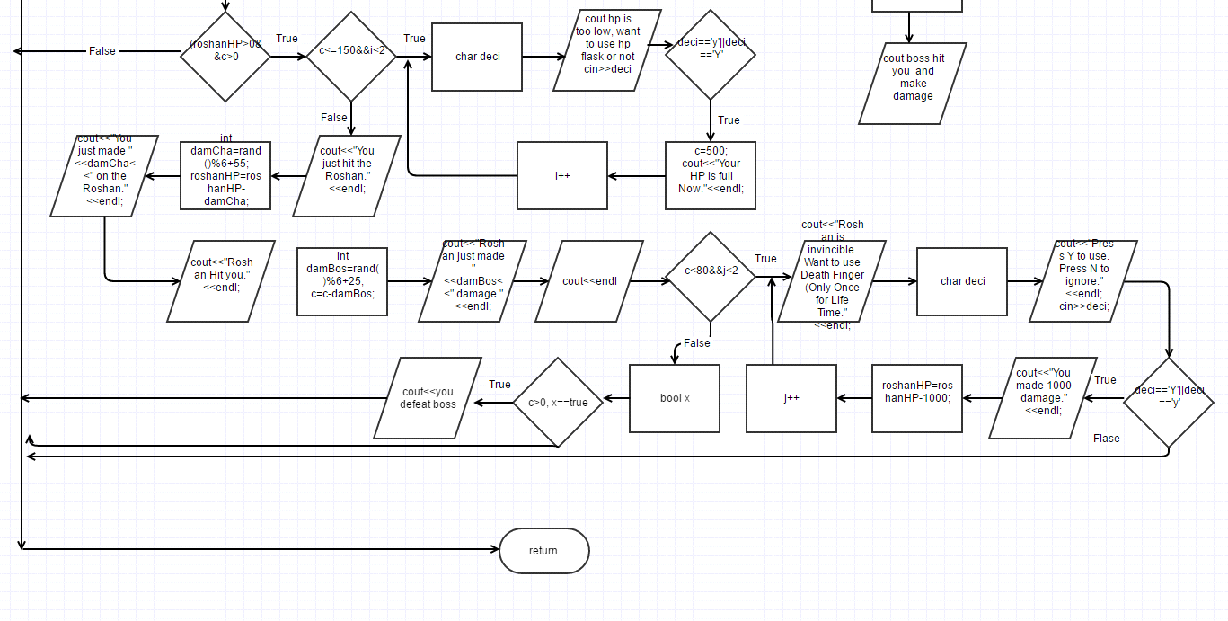

**Major Variables**

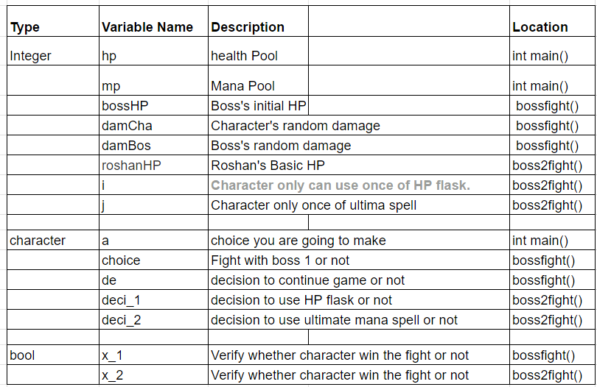

**Constructs**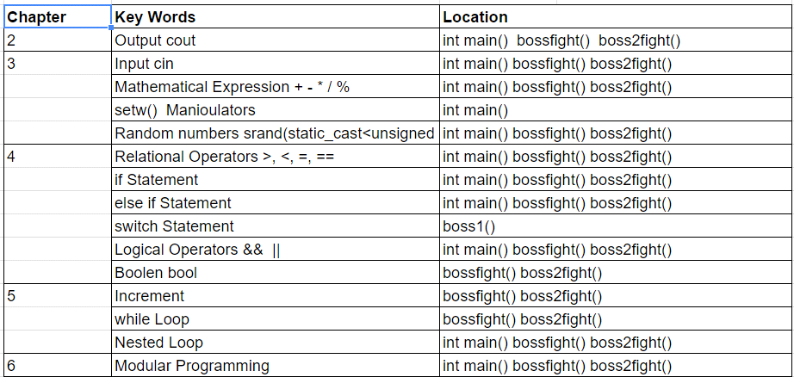

|  |
| --- |
|  |

**Reference**

**Textbook: Tony Gaddis*, Starting out with C++ from Control Structures through Objects*, 8th Edition.**

**Program**

**#include <cstdlib>**

**#include <iostream>**

**#include <ctime>**

**#include <iomanip>**

**using namespace std;**

**//User Libraries**

**//Global Constants**

**//Function Prototype**

**int boss1(int,int);**

**void bossfight(int,int);**

**void boss2fight(int,int);**

**//Execution Starts Here**

**/\***

**\***

**\*/**

**int main(int argc, char** argv) {**

**//Set up random number seed**

**srand(static_cast<unsigned int>(time(0)));**

**cout<<"Welcome To Your Journey."<<endl;**

**cout<<endl<<endl;**

**char a;//choice that you are going to make**

**cout<<"Start or not?? Press any keys to start. "<<**

**"Press N or n to quit."<<endl;**

**//Input "no" choice**

**cin>>a;**

**if(a=='n'||a=='N')**

**{**

**cout<<"Game Over!!!"<<endl;**

**return 0;**

**}**

**//Introduction to the character**

**cout<<"Your Initial Condition: "<<endl;**

**//Declare Variables;**

**int hp=500,mp=50;//Health Pool, Mana Pool, Experience Pool**

**//output initial condition of character**

**cout<<"HP: "<<hp<<setw(4)<<" MP: "<<mp<<" Basic Damage: 55-60."<<endl;**

**boss1(hp,mp);**

**return 0;**

**}**

**/**************************Make choice to fight or not*************************/**

**int boss1(int a,int b)**

**{**

**char choice;**

**cout<<"You met a boss. You want to fight or not."**

**<<" Press n to escape, Press y to fight."<<endl;**

**cin>>choice;**

**//Make decision to fight with boss or not**

**switch(choice)**

**{**

**case 'Y':**

**case 'y': bossfight(a,b);break;**

**case 'N':**

**case 'n':**

**{**

**cout<<"You decide to choose a small path to avoid the boss, ";**

**cout<<"but you die because of spike trap."<<endl;break;**

**}**

**}**

**return a,b;**

**}**

**/********************Start to fight with the first boss************************/**

**void bossfight(int c,int d)**

**{**

**//c is character's HP, d is character's MP**

**int bossHP=500;//Boss's initial HP**

**while(bossHP>0&&c>0)**

**{**

**//Character's round to hit boss**

**cout<<"You just hit the boss."<<endl;**

**int damCha=rand()%6+55;//Character's random damage**

**bossHP=bossHP-damCha;//Boss's hp left**

**cout<<"You just made "<<damCha<<" on the boss."<<endl;**

**//Boss' round to hit character**

**cout<<"Boss Hit you."<<endl;**

**int damBos=rand()%6+25;//Boss's random damage**

**c=c-damBos;//Character's hp left**

**cout<<"Boss just made "<<damBos<<" damage."<<endl;**

**cout<<"Character's current HP is "<<c<<endl;**

**cout<<endl<<endl;**

**}**

**bool x;**

**if(c>0) x=true;**

**if(x==true) cout<<"You defeated Boss."<<endl;**

**char de;**

**cout<<"Do you want to continue?"<<endl;**

**cin>>de;**

**if(de=='y'||de=='Y')**

**{**

**//Second Boss Fight**

**boss2fight(c,d);**

**}**

**else**

**{**

**cout<<"Game Over. You Haven't Finished Your Journey."<<endl;**

**}**

**}**

**/************************Second Boss Fight************************************/**

**void boss2fight(int c,int d)**

**{**

**cout<<"After a long travel, you meet a another Boss, Roshan."<<endl<<endl;**

**cout<<"The Battle Begins."<<endl;**

**int roshanHP=2000;//Roshan's Basic HP**

**int i=1;//Character only can use once of HP flask.**

**int j=1;//Character only once of ultima spell**

**//HP flask taking**

**while(roshanHP>0&&c>0)**

**{**

**//Have HP Flask**

**while(c<=150&&i<2)**

**{**

**char deci;//make the decision to take hp flask or not**

**cout<<"Warning!! Your HP is too low, have HP Flask?"<<endl;**

**cout<<"Press Y to use. Press N to ignore."<<endl;**

**cin>>deci;**

**if(deci=='y'||deci=='Y')**

**{**

**c=500;**

**cout<<"Your HP is full Now."<<endl;**

**}**

**i++;**

**}**

**//Character's round to hit boss**

**cout<<"You just hit the Roshan."<<endl;**

**int damCha=rand()%6+55;//Character's random damage**

**roshanHP=roshanHP-damCha;//Boss's hp left**

**cout<<"You just made "<<damCha<<" on the Roshan."<<endl;**

**//Roshan' round to hit character**

**cout<<"Roshan Hit you."<<endl;**

**int damBos=rand()%6+25;//Roshan's random damage**

**c=c-damBos;//Character's hp left**

**cout<<"Roshan just made "<<damBos<<" damage."<<endl;**

**cout<<"Character's current HP is "<<c<<endl;**

**cout<<endl<<endl;**

**//Mana flask**

**while(c<80&&j<2)**

**{**

**cout<<"Roshan is invincible. Want to use Death Finger (Only Once for Life Time."<<endl;**

**char deci;**

**cout<<"Press Y to use. Press N to ignore."<<endl;**

**cin>>deci;**

**if(deci=='Y'||deci=='y')**

**{**

**cout<<"You made 1000 damage."<<endl;**

**roshanHP=roshanHP-1000;**

**}**

**j++;**

**}**

**}**

**bool x;**

**if(c>0) x=true;**

**if(x==true) cout<<"You defeated Boss."<<endl;**

**else cout<<"You have been Defeated."<<endl;**

**}**

**Status API Training Shop Blog About**

**© 2016 GitHub, Inc. Terms Privacy Sec**